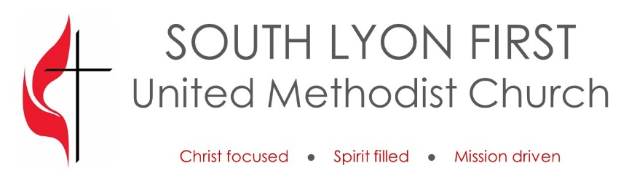

Special Donation Form

Name of Donor: Click here to enter donor name.
Name of Financial Institution: Click here to enter name of financial institution.
Expected Total Amount of Donation: $ Click here to enter amount of donation.
Expected Date of Donation: Click here to enter date.

Number of Months that donation covers: Click here to enter number of months.

Distribution of Donation:
Operating Fund: $ Click here to enter amount.
Mission of the Month: $ Click here to enter amount
Other $ Click here to enter amount. Other description: Click here to enter description.

Method of Donation (Please select one):

☐ Check made out to the church and sent to First United Methodist Church, 640 South Lafayette St., South Lyon, MI 48178

☐ Electronic transfer to PNC Bank, Routing/Transit # 021052053, Account # 89298693

☐ Stocks, bonds or mutual funds (special instructions will be provided for this option)

