Authorization ForM

Organization Name: First United Methodist Church of South Lyon

Customer Id # |  |  |  |  | DATE
Effective date of authorization: _____/_____/_____

Type of authorization: | - New authorization |  | - Change payment amount |  |  |  | - Change payment date
 | - Change banking information |  | - Discontinue electronic payment
Last Name |  |  |  | First Name

Address
City |  |  |  |  |  | State |  | Zip

Email Address

Payment Frequency: Recurring (select one):  Monthly on the 1st  Monthly on the 15th

Date of first payment: ______/______/______ Amount of recurring payment: $____________

Church Fund Designations and Amounts:

Operating Fund : ___________

Mission of the Month: ____________
Total: __________________

CHECKING / SAVINGS | Please debit payment from my (check one):  - Savings Account (contact your financial institution for Routing #)  - Checking Account (staple a voided check below) | Routing Number: _____________________________  Valid Routing # must start with 0, 1, 2, or 3  Account Number: _____________________________  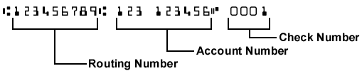
I authorize the above organization to process debit entries to my account. I understand that this authority will remain in effect until I provide reasonable notification to terminate the authorization.

Authorized Signature:__________________________________________________________ Date:________________

Please staple voided check here

